**React HOL 1**

**Define SPA and its Benefits**

SPA is a type of web application that loads a single HTML page and dynamically updates content as the user interacts with the app, without refreshing the page.

1. Faster performance
2. Smooth user experience
3. Easier mobile responsiveness
4. Efficient caching

**Define React and Identify its Working**

**React** is a JavaScript library for building **user interfaces**, developed and maintained by Facebook. It follows a **component-based** architecture, allowing developers to build reusable UI pieces.

**Difference between SPA and MPA**

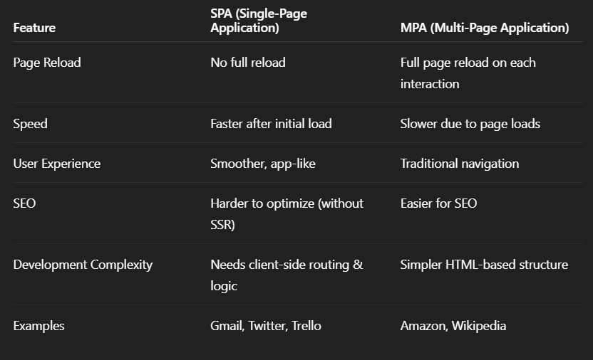

**Pros and Cons of SPA**

Pros:

Fast, responsive UI

Reduced server load

Easier to develop mobile-friendly experiences

Cons:

Poor SEO unless using SSR

Initial load time can be large

More complex client side logic

**Explain about React**

1. It is a JavaScript Library
2. Focuses on a building UI components.
3. Uses JSX syntax
4. Is declarative
5. Manages component state and lifecycle methods

**Define Virtual DOM**

Virtual DOM is a lightweight JavaScript representation of the real DOM.

**Features of React**

1. Component – Based Architecture
2. JSX Syntax
3. Virtual DOM
4. Unidirectional Data Flow
5. Declarative UI
6. React Hooks
7. React Router
8. React Native

